Stress Eating Tracker SRS

Lemonhut | Home

Stress Eaters Anonymous

Kevin D. Mitchell

2020

# Table of Contents

Table of Contents 1

Changelog 2

Introduction 3

Purpose 3

Intended Audience 3

Intended Use 3

Scope 3

Definitions and Acronyms 3

Background Information 3

Pavlovian Theory 3

Emotional Eating 4

Positive Reinforcement 4

Conclusion 4

Overall Description 5

User Needs 5

Assumptions and Dependencies 5

System Features and Requirements 6

Functional Requirements 6

External Interface Requirements 6

Non-Functional Requirements 7

# Changelog

|  |  |  |
| --- | --- | --- |
| Date | Name | Purpose |
| 3/20/20 | Kevin Mitchell | Initial creation and definition of project |
|  |  |  |
|  |  |  |
|  |  |  |
|  |  |  |
|  |  |  |
|  |  |  |

# Introduction

## Purpose

The purpose of the Stress Eating Tracker is to track not only a user’s diet, but also what external and internal stressors and factors contribute to the diet. According to Pavlovian Theory, people’s behaviors can be triggered by certain stimulus and this tracker seeks to, over time, zero in on what stimulus cause users to eat. By doing this, the tracker can help users determine what factors and stimulus cause the hunger response and react accordingly.

## Intended Audience

Any person that wishes to track their diet/nutrition and/or learn what behaviors/stimulus cause that user to eat the way they do.

## Intended Use

Daily input of the user’s eating behaviors as well as stimulus they encounter.

## Scope

This application should allow users to track their diet in its entirety while also tracking any stimulus they share. Over time, the application should show users a correlation between stimulus and intake.

The app will NOT be able to demonstrate causation, but will point out correlations. This will allow the user to determine if the stimulus are causing the reaction or if it is merely correlated.

## Definitions and Acronyms

|  |  |
| --- | --- |
| Word | Definition |
|  |  |
|  |  |
|  |  |
|  |  |
|  |  |
|  |  |
|  |  |

## Background Information

### [Pavlovian Theory](https://online.husson.edu/consumer-behavior-pavlovian-theory/)

Pavlovian theory is a learning procedure that involves pairing a stimulus with a conditioned response. A simple application of Pavlovian theory is the response that some consumers have when they hear the word “sale.” It can generate an urge to shop, even if people have no specific need at the time. As consumers receive verified experiences with brands, a conditioned response is possible. ***(Sourced from linked article above)***

### [Emotional Eating](https://www.helpguide.org/articles/diets/emotional-eating.htm)

We don’t always eat just to satisfy physical hunger. Many of us also turn to food for comfort, stress relief, or to reward ourselves. And when we do, we tend to reach for junk food, sweets, and other comforting but unhealthy foods. …when eating is your primary emotional coping mechanism—when your first impulse is to open the refrigerator whenever you’re stressed, upset, angry, lonely, exhausted, 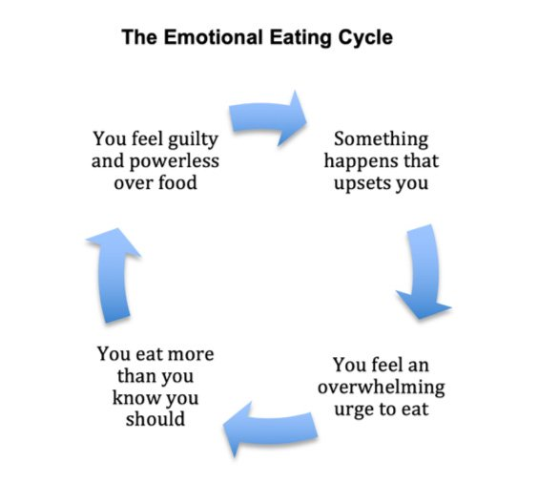or bored—you get stuck in an unhealthy cycle where the real feeling or problem is never addressed. ***(Sourced from linked article above)***

### [Positive Reinforcement](https://www.verywellmind.com/what-is-positive-reinforcement-2795412)

In operant conditioning, positive reinforcement involves the addition of a reinforcing stimulus following a behavior that makes it more likely that the behavior will occur again in the future. When a favorable outcome, event, or reward occurs after an action, that particular response or behavior will be strengthened. ***(Sourced from linked article above)***

One of the easiest ways to remember positive reinforcement is to think of it as something being added. By thinking of it in these terms, you may find it easier to identify real-world examples of positive reinforcement. ***(Sourced from linked article above)***

### Conclusion

Pavlovian Theory give credence to the idea that a user may have been subconsciously “trained” to associate some stimulus with hunger, over eating, or stress eating. Certain external stimulus may trigger an emotional response that leads the user to emotional eating.

By tracking what stimulus and stressors a user encounters (both positive and negative), as well as the emotional state of the user as a result of these stimulus, we can find correlations between a user’s behavior and eating.

# Overall Description

## User Needs

* **FR1:** User should be able to input weight and weight-loss goals
* **FR2:** User should be able to track foods and nutrition
* **FR3:** User should be able to input stimuli both internal and external
* **FR4:** User should see correlations drawn from food intake and stimulus

## Assumptions and Dependencies

* **EX1:** Google API integration
* **EX2:** Cloud service for application for syncing across multiple devices will need a server
* **EX3:** Application should support iOS, Android, and a web interface

# System Features and Requirements

## Functional Requirements

|  |  |
| --- | --- |
| Tag | Requirement |
| FR1.1 | User should be able to input current weight |
| FR1.2 | User should be able to see all weights inputted |
| FR1.3 | User should be able to set a goal weight |
| FR1.4 | User should be able to track weight-loss progression |
| FR2.1 | User should be able to set calorie goal |
| FR2.2 | User should be able to set carbohydrate goal |
| FR2.3 | User should be able to set protein goal |
| FR2.4 | User should be able to set fat goal |
| FR2.5 | User should be able to add food from pre-existing database |
| FR2.6 | User should be able to remove food from diary |
| FR2.7 | User should be able to review diary |
| FR2.8 | User should be able to see when they do not meet their goals |
| FR3.1 | User should be able to input a single external stimulus |
| FR3.2 | User should be able to input multiple external stimulus in bulk |
| FR3.3 | Application should recommend common external stimulus when user attempts to add |
| FR3.4 | Application should recommend common external stimulus from the user’s past entries |
| FR3.5 | User should be able to input a single internal stimulus |
| FR3.6 | User should be able to input multiple internal stimulus in bulk |
| FR3.7 | Application should recommend common internal stimulus when user attempts to add |
| FR3.8 | Application should recommend common internal stimulus from the user’s past entries |
| FR3.9 | Application should display frequency of stimulus encountered |
| FR4.1 | Application should display to the user correlations between eating more than the user’s caloric goals and common stimulus when this happens |
| FR4.2 | Application should display to the user correlations between eating certain foods and common stimulus when this happens |

## External Interface Requirements

|  |  |
| --- | --- |
| Tag | Requirement |
| EX1.1 | Application will need to Interface with Google oAuth |
| EX1.2 | Application will need to interface with Google’s nutrition database |
| EX1.3 | Application will need to interface with Apple HealthKit |
| EX1.4 | Application will need to store information for users that do not wish to integrate HK or Fit |
| EX2.1 | Online database will store user data |
| EX3.1 | Application will need to have web interface |
| EX3.2 | Application will need to run on iOS |
| EX3.3 | Application will need to run on Android |

## Non-Functional Requirements

|  |  |
| --- | --- |
| Tag | Requirement |
| NF1 | Web Application must be responsive to allow for mobile browser use |
|  |  |
|  |  |
|  |  |
|  |  |
|  |  |
|  |  |

# References

## Sign in With Apple

<https://developer.apple.com/sign-in-with-apple/get-started/>

## Google OAuth

<https://developers.google.com/identity/protocols/oauth2>

## Google Fit API

<https://developers.google.com/fit/overview>